***Curriculum vitae***

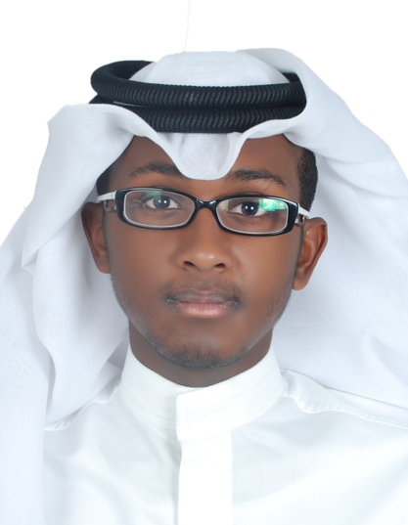***Personal Information:***

***Name: Suhaib Jamal Alyaqoob***

***CPR : 970902794***

***Nationality : Bahraini***

***Marital Status : Single***

***Sex : Male***

***Place and Date of Birth:*** ***6/9/1997, AlRiffa***

***Address: House 1512 /Road 1121 /Block 1211***

***Contact Number : 33805615 / 39699707***

***E-Mail :*** [***Suhaibalyaqoob@gmail.com***](mailto:Suhaibalyaqoob@gmail.com)

***Educational attainment:***

***(2012-2015) Hamad Town Secondary Boys (Commercial Division)***

***Languages:***

***Arabic (Speaking and Writing)***

***English (Speaking and Writing)***

***Hobbies and Skills:***

1. ***Well Organizing***
2. ***Computer***